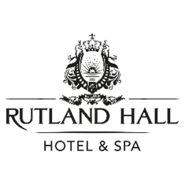

FOOD & BEVERAGE ASSISTANTS
Rutland Hall Hotel sits in 70 acres of beautiful parkland on the shores of Rutland Water. We are now recruiting for Food & Beverage (F&B) Service Team members to work on a casual basis across various shifts including evenings and weekends dependent on our business needs.
F&B duties will include working in our ever-popular Blossoms restaurant, lounge and bar, and in our events, conferences and weddings venues - the Pavilion Venue and the Lakeview Suite.
Shifts can vary depending on whether you're working breakfast which will means you'll need to be an early riser or if you're working an evening function which, on occasions, could mean you finish after midnight.
Experience is not essential for these roles. We are looking for team members who are 18 years of age or above, with an enthusiastic and proactive attitude and who are people people! It is essential that you like being around others and are motivated to naturally smile and offer a first class, attentive service to each and every one of our guests.

F& B Assistants will ideally have:
- A positive can-do attitude
- A strong customer service focus and desire to serve
- Flexibility to working hours
- A confident, warm, and welcoming personality
- Impeccable grooming and personal presentation
- Good communication skills

What we offer:

£10.15 per hour, paid monthly with fulltime and parttime hours available.
- Free car parking
- Colleague food while on duty
- Colleague discounts
- Colleague social events
- 24-hour access to Employee Assistant Programme
If you are interested, please send in your CV. We look forward to hearing from you!
By applying for this role, you are consenting for us to hold and process your data in compliance with the General Data Protection Regulations. If you have any questions or wish to exercise your right to access, erase or restrict the holding or processing of your data please contact us and we will respond to your query as soon as possible.

